GRANARD MUNICIPAL DISTRICT

Corporate Affairs,
Aras an Chontae,
LONGFOIRT.

21st March 2018.

To: Each Member of Granard Municipal District.

Dear Member,

You are requested to attend Meeting of Granard Municipal District to be held in
Granard Community Library on Tuesday, 27th March 2018 at 3.30 p.m. to transact business, as set out on the Agenda hereunder.

Yours sincerely,
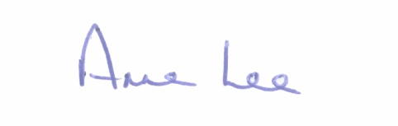

_______________
Anne Lee,
Meetings Administrator.

AGENDA

Prayer before meeting.

1. Confirmation of the following Minutes of Granard Municipal District Meetings -
- Meeting held on the 30th January 2018.
- Committee Meeting held on the 27th February 2018.
- Special Meeting held on the 27th February 2018

2. Matters arising from Minutes.

3. Area Engineer’s Progress Report.

4. Consideration of applications for funding under the 2018 Community Grant Support Scheme - report enclosed.

5. Consideration of request from Ballinamuck Community Enterprise Society Ltd. for a Civic Reception in Aras on Chontae on Friday, 27th July 2018 to honour the 21st Anniversary of the the Ballinamuck & Essert de Belfort Twinning Agreement.

6. Consideration of the taking in charge of “Loughan Hill”, Drumlish,
Co. Longford - details enclosed.

7. Notices of Motions submitted by Councillors –

Councillor P.J. Reilly.

“I propose that funding be sought for a 'Low Cost Safety Scheme' for Howdin’s Cross on the R194 Granard/Ballinalee Road as a number of accidents have occurred at this bend.”

“That a programme be put in place to clean and maintain Direction Signs”.

Councillor Michael Carrigy.

“I call on Longford County Council to prioritise funding for a playground in Killoe in this year’s Clar programme.”

“Could I get an update on our application for Low Cost Safety Schemes at Houden’s Cross, Ballinalee and at the Ohill junction, Ennybegs.”

8. A.O.B.

